**LaoVISTA: Virtual Information System for Municipality of LAOAC**

A proposed Capstone Project

presented to the faculty of the

College of Information and Technology Education

Urdaneta City University

In Partial Fulfillment of the Requirements

for the degree Bachelor of Science in Information Technology

by

Pamela G. Marquez

John Miko T. Almojera

Aedriel Kenneth A. Flores

Jean Kyla M. Garcia

Franklin Cloyd A. Jacinto

Mark Christopher M. Lagundi

May 2025

This proposed Capstone Project Study entitled **LaoVISTA: Virtual Information System for Municipality of LAOAC** prepared and submitted by Pamela G. Marquez John Miko T. Almojera Aedriel Kenneth A. Flores, Jean Kyla M. Garcia, Franklin Cloyd A. Jacinto, Mark Christopher M. Lagundi, has been examined and is recommended for approval and acceptance.

EHERSON G. VALDEZ, LPT, MIT

Adviser

________________________________________________________________________

APPROVED by the Capstone Project Study Committee with a grade_ of on November 29, 2023.

Capstone Project Study Committee

JOEMARK M. LOPEZ,MIT ARLYN L. AQUINO,MIT

Panel Member Technical Panel

ANTHONY G. MARQUEZ, LPT, MIT

Chairman

ACCEPTED in partial fulfillment of the requirements for the degree Bachelor of Science in Information Technology.

JULIE ANN L. MALICAY, MIT EHERSON G. VALDEZ, LPT, MIT

College Research Coordinator Program Head, BSIT

JOHANNS B. RABAGO, LPT, MIT

College Dean

**TABLE OF CONTENTS**

|  |  |  |
| --- | --- | --- |
|  |  | PAGE |
| TITLE PAGE………………………………………………………………… | | 1 |
| APPROVAL SHEET………………………………………………………… | | 2 |
| TABLE OF CONTENTS…………………………………………………… | | 3 |
| LIST OF TABLES…………………………………………………………… | | 6 |
| LIST OF FIGURES…………………………………………………………. | | 7 |
| LIST OF PLATES…………………………………………………………… | | 8 |
| **Chapter** | |  |
| **1** | **INTRODUCTION**………..…………………………………….. | 16 |
|  | Project Context……..………………………………………….. | 16 |
|  | Company Profile……………………………………………….. | 21 |
|  | Purpose and Description ……………………………………. | 23 |
|  | Conceptual Framework………………………………………. | 25 |
|  | Objectives of the Study………………………………………. | 26 |
|  | Scope and Limitations………………………………………. | 27 |
|  | Definition of Terms……………………………………………. | 29 |
| **2** | **REVIEW OF RELATED LITERATURE AND SYSTEMS** | 32 |
| **3** | **METHODOLOGY**……………..……………………………….. | 42 |
|  | Research Approach……………………………………………. | 42 |
|  | Software Development Methodology………………………. | 44 |
|  | Requirement Analysis………………………………………… | 50 |
|  | Sources of Data………………………………………………… | 52 |
|  | System Requirements ……………………………..………… | 53 |
| **REFERENCES**……………………………………………………………… | | 107 |
| **APPENDICES**………………………………………………………………. | | 114 |
| **A** | Communication Letter to the Client………………………. | 115 |
| **B** | Interview Guide…………………………………………….….. | 116 |
| **C** | Acceptability Questionnaire for Admin.……………...….. | 119 |
| **D** | Acceptability Questionnaire…………………………………. | 124 |
| **E** | Entity Relationship Diagram…….…………...…………….. | 127 |
| **F** | Data Flow Diagram.……………………….………………….. | 129 |
| **G** | Use Case Diagram…………………………………………….. | 143 |
| **H** | Gantt Chart……….……………………………………………. | 144 |
| **CURRICULUM VITAE**……………………………………………………. | | 196 |

**LIST OF TABLES**

|  |  |  |
| --- | --- | --- |
| Table | Title | Page |
| 1 | Table of Respondents | 50 |
| 2 | Software Requirements for Development | 51 |
| 3 | Software Requirements for Development | 52 |
| 4 | Hardware Requirements for Development | 53 |
| 5 | Desktop Software Requirements for Development | 54 |
| 6 | Level of Users/People ware | 55 |

**LIST OF FIGURES**

|  |  |  |
| --- | --- | --- |
| Figure | Title | Page |
| 1 | Organizational Chart | 20 |
| 2 | Research Paradigm | 24 |
| 3 | Extreme Programming Model | 42 |

**LIST OF PLATES**

|  |  |  |
| --- | --- | --- |
| Plate | Title | Page |
| 1 | Barangay | 157 |
| 2 | PWA guide installation | 158 |

**Chapter 1**  
**INTRODUCTION**

**Project Context**

In recent years, the adoption of Information Management Systems (IMS) has played a crucial role in improving data organization, service efficiency, and decision-making processes in both public and private sectors. Various studies emphasize the importance of digital governance, highlighting how automated systems enhance administrative efficiency, transparency, and accessibility. Research by Ahmed et al. (2023) and Dang & Vartiainen (2022) underscores the role of Management Information Systems (MIS) in streamlining operations, while Miao & Zhao (2023) explore how digital information systems support sustainable and efficient public service delivery. Similarly, local studies such as those by Dela Cruz (2020) and Reyes & Bautista (2021) demonstrate the impact of barangay-level information systems in improving resident profiling, document processing, and community engagement.

Despite these advancements, many barangays in the Philippines still struggle with outdated, manual processes that slow down essential services such as resident profiling, document issuance, grievance handling, and financial management. Traditional paper-based systems often result in delays, lost records, and inefficiencies, making it difficult for local officials to track requests and maintain accurate community data. Moreover, lack of digital integration among barangays hinders

efficient communication and coordination, further complicating governance.

Given these challenges, there is a pressing need for a comprehensive, technology-driven solution to optimize municipal services. The LaoVISTA: Innovative System Information of Laoac is proposed as a centralized, digital platform to enhance barangay and municipal operations, ensuring faster, more efficient, and transparent service delivery. This system will provide a solution to the problems faced by local government units by improving service processes, integrating data, and facilitating communication among officials and residents. The system will cater to various user roles, including the ABC President, Barangay Captain, Barangay Secretary, and residents, ensuring that all stakeholders benefit from a more efficient governance model. The LaoVISTA system aims to address these inefficiencies and provide an innovative solution to modernize governance in Laoac.

**Company Profile**

**Vision & Mission** The Municipality of Laoac envisions itself as an Agro-Economic hub in Pangasinan, fostering a safe, sustainable, and agriculturally conducive environment that supports a self-reliant economy. It aims to be home to competitive, socially responsible Laoakenians, led by participative and consensus-driven leaders. Laoac’s mission is to ensure peace, order, and security, making it a disaster-resilient community through the collaboration of government, law enforcers, and citizens. The municipality is committed to being drug-free, enforcing environmental laws, maintaining safety-compliant infrastructures, and mobilizing efforts to protect public welfare. Laoac traces its name to the Ilocano phrase “Nag-la-oa daytoy nga tay-aken,” meaning “How wide this plain is!”—a remark by early settlers in the late 1800s, inspired by the area’s vast, fertile lands, from which the name Laoac was derived.

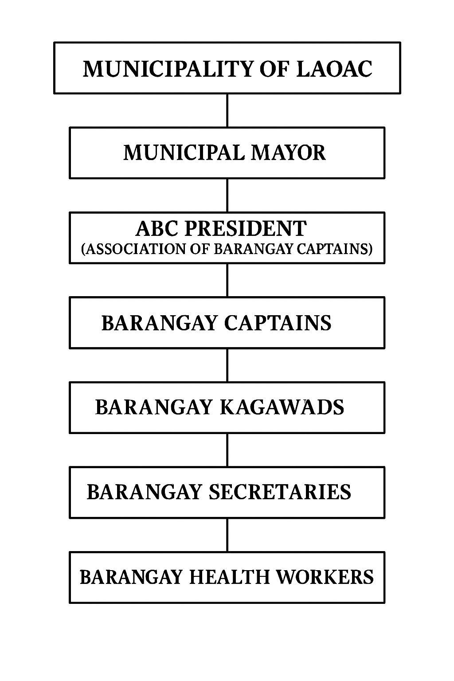

Figure 1. Organizational Chart of the Municipality of Laoac

**Purpose and Description**

This system aims to centralize data management, streamline administrative processes, and provide improved access to public services for various stakeholders, including the Municipal Government of Laoac, residents, local businesses, barangay employees and officials and researchers.

The primary motive for the implementation of The LaoVISTA: Innovative System Information of Laoac in the Municipality of Laoac is to revolutionize the way Barangay functions and caters to its people. Manual systems are always slow, inaccurate, and time-consuming, thereby hampering the ability of municipalities to respond to the needs of their people. LaoVISTA: Innovative System Information of Laoac would correct such concerns through the computerization of substantial administrative procedures, improved handling of data, and providing the Barangay officials appropriate equipment to make sensible decisions and react to citizens' needs right away in the Municipality of Laoac.

This study aims to provide various stakeholders with improved access to services, information, and resources. The system will provide services such as Barangay Document Processing, Grievance and Feedback System, Service Request System and Announcements and News, which will enhance administrative operations, facilitate better decision-making, and improve overall governance.

The following are benefiting the study as follows:

To Municipal Government of Laoac. This study will enable the local government to enhance data management, improve decision-making, and streamline processes for better governance by utilizing digital tools and systems.

To Barangay Officials. This study will improve productivity and workflow for municipal staff by centralizing data, automating processes, and enhancing communication.

To Local Businesses. This study will simplify transactions related to registration, permits, and compliance, making these processes more efficient through the system.

To Residents. This study will serve as a digital bridge between the local government and its citizens, improving accessibility to information and services.

To Researchers. This study would help the researchers to improve their knowledge and create a secure and valuable system for their clients.

To Future Researchers. This study may serve as a basis for gathering information for future research.

**Conceptual Framework**

The LaoVISTA: Innovative System Information development life cycle starts with defining requirements and ends with system deployment. The framework guides data gathering, analysis, design, and implementation activities to meet the specific needs of the Municipality of Laoac. Data is collected through various methods, and an evaluation/analysis process consolidates the data. System development involves code, testing, and design using agile techniques. Evaluation/analysis ensures system security, functionality, and performance. The Output phase involves system implementation, including staff training, data migration, and support. The project proposal aims to improve governance and service delivery.

transparency, and accountability gain for Municipality of Laoac. It is gauged in a range of measures such as user satisfaction, efficiency of processes, and data improvement in accuracy.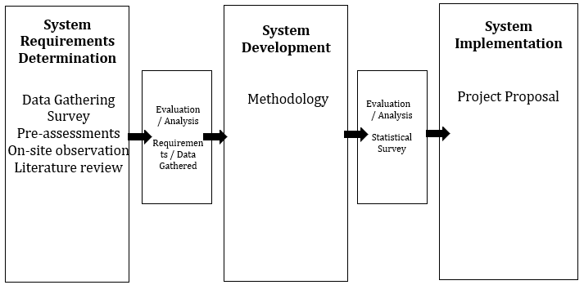

**System Development**

Software Development Life Cycle

(Extreme Programming)

LaoVISTA: “Virtual Information System for Municipality of LAOAC”

Figure 2. IPO Diagram of Proposed Study

**Objectives of** **the Study**

The primary objective of this study is to develop LaoVISTA, a Virtual Information System for the Municipality of Laoac. This system aims to streamline barangay operations by digitizing resident records, document processing, service requests**.** Specifically, the study will work to meet the following objectives:

1. To identify the requirements needed in the development of the proposed system along with the areas of:
   1. Resident and Officials Profiling Management;
   2. Barangay Operations and Services;
   3. Announcements and News; and
   4. Report Generation;
2. To identify the design consideration that should be implemented in the development of the proposed study in terms of:
   1. architectural framework;
   2. content and features; and
   3. users of the system;
3. To measure the level of user’s acceptability of the proposed system.

**Scope and Limitations**

This study aims to design and develop LaoVISTA: Virtual Information System for the Municipality of Laoac, a hybrid platform composed of a mobile application for residents and a web-based system for barangay officials. It serves as a centralized digital solution for managing barangay services, improving efficiency and accessibility in local governance.

The mobile application is exclusively developed for residents, enabling them to register securely, manage personal profiles, and access essential barangay services. The app handles detailed data for various resident categories, including Senior Citizens, Persons with Disabilities (PWDs), Solo Parents, and Indigenous Peoples (IPs), ensuring accurate classification and compliance with data privacy protocols.

Residents can use the app to request barangay documents such as clearances and certificates, with real-time tracking of request status. It also supports service scheduling. In-app notifications are used to keep residents updated on the progress of their requests. Moreover, the app acts as an information hub, giving residents access to local announcements, events, and updates through push notifications.

However, the system has limitations. It is specifically designed for the Municipality of Laoac and is not built for use in other municipalities. It does not include payroll management for barangay employees or a full financial system—only basic online payments for document fees are supported. In addition, while residents use a mobile interface, barangay officials access the system through a web-based admin portal, and the mobile version is not intended for administrative tasks.

**Definition of Terms**

This section lists the study’s definition of terms:

Admin.Short for administration, it is the activity or process of organizing an institution or organization (Collins Dictionary). This study pertains to the designated user who supervises the barangay information system, managing resident data, processing requests, monitoring activities, and ensuring smooth system functionality.

Announcements. It is a public notification or declaration (Merriam-Webster). In this study, it refers to any message created and published by barangay or municipal officials through the LaoVISTA system to keep residents informed about community matters.

Automation. It is the technique of making an apparatus, a process, or a system operate automatically (Merriam-Webster). In this study, it refers to the process of digitizing barangay operations to minimize manual work and increase efficiency.

Barangay Document Processing. It refers to the procedure of issuing official documents such as barangay clearances, certificates of residency, and permits. In this study, it is managed through the proposed system to ensure faster and more organized transactions. According to Garcia & Santos (2021), automating local government document processing improves efficiency, reduces errors, and enhances public service delivery.

E-Governance. It is the use of information technology to provide government services, facilitate information exchange, enable communication transactions, and integrate various stand-alone systems between the government and citizens (UN e-Government Survey, 2020). In this study, it refers to how LaoVISTA utilizes digital tools to ensure transparent and efficient service delivery. As stated by Bwalya & Mutula (2016), e-governance increases government accountability and promotes citizen participation by improving access to information and services. Manual Process. It involves human effort and rely on personal skills (as on a website). This study refers to the traditional, paper-based method used by barangay offices before the implementation of the system.

Real-Time Monitoring System. It is the delivery of continuously updated data about systems, processes, or events (TechTarget). This study refers to a feature of the system that allows officials to observe service requests and system activities as they happen.

Real-Time Notification. It is a message sent from the server to the client application in real time, providing immediate updates or alerts. In this study, it refers to notifications delivered from the LaoVISTA server to the user’s device, providing real-time updates on requests, documents, or other important announcements.

Requirement. It is something wanted or needed (Merriam-Webster). In this study, it refers to the specific document, information, or criteria that a resident user of LAOVISTA must submit or fulfill to complete the processing of a request.

Resident Database Management. It refers to the structured system of storing and organizing resident records. In this study, the feature is used to maintain updated and secure resident profiles for documentation and service delivery.

Service Request System. It is a platform that manages requests for various services (ScienceDirect). This study refers to the feature within the LaoVISTA platform that enables residents to file, track, and receive updates on their barangay-related service requests, ensuring more efficient and transparent public service delivery.

Virtual Information System. It refers to a centralized, computerized platform used to manage, store, and communicate information digitally. In this study, it serves as the core of LaoVISTA, enabling integrated service delivery, secure data management, and streamlined communication between residents and local government officials in Laoac.

**Chapter 2**

**REVIEW OF RELATED LITERATURE AND SYSTEMS**

This chapter explores existing studies, theories, and technological advancements on Information Management Systems that focus on the efficient collection, storage, processing, and retrieval of data, highlighting key developments, challenges, and best practices that contribute to optimizing information flow and decision-making within organizations.

**Foreign Literature**

Ahmed et al. (2023) argue that a strategically developing economy requires adequate support for management information systems. Over time, control systems have evolved from autonomous subsystems into comprehensive IT environments. These ecosystems, in turn, leverage innovative and intelligent potential by applying the principles of space-time independence and scalability in both processes and communications. Moreover, digital transformations primarily focus on market formation and expansion, fostering promising and adaptive economic business models. As a result, they influence the competitive positioning of enterprises and companies while also shaping the direction of market evolution.

According to Dang, D., & Vartiainen, T. (2022), In recent years, there has been a considerable amount of information systems (IS) research on digital strategy. However, it is not clear how digital strategy is taught in higher education. We are living in a rapidly digitalizing world

where new opportunities are being created at the same time as traditional business models are being disrupted. It has been predicted that 40% of today’s Fortune 500 companies on the S&P 500 will disappear by 2025 due to technological change (Nanterme, 2021; Vayghan, 2023). Therefore, there is an urgency for organizations to adopt new strategies based on digital technologies.

As stated by Nurnaninsih et al. (2023) In the dynamic landscape of the digital age, effective knowledge management has become paramount for organizations aiming to harness information and drive innovation. Knowledge Management Systems (KMS) emerge as crucial tools, facilitating the storage, sharing, and creation of knowledge. By systematically analyzing scholarly literature, this research contributes to a comprehensive understanding of knowledge management's evolving role in the digital age, shedding light on its implications for both theory and practice.

Miao and Zhao (2023) state that, under the background of increasingly prominent environmental problems, the establishment and application of digital information management systems driven by the digital economy have brought new opportunities and challenges to the green transformation of manufacturing enterprises. *Therefore,* considering the micro level of Chinese manufacturing enterprises, it is worth exploring whether the adoption of information management systems truly promotes the improvement of their green transformation **level.**According to Alzhrani (2022), In the digital age, firms are increasingly relying on data-driven decision-making to maintain a competitive advantage. A Management Information System (MIS) plays a crucial role in this process by collecting, processing, and analyzing data to provide valuable insights. Digital firms—companies that operate primarily through online platforms, cloud-based services, and automated business models—utilize MIS to enhance strategic planning, operational efficiency, and customer relationship management.

**Local Literature**

Dela Cruz (2021) highlighted the significance of the Barangay Management Information System (BMIS) in Philippine barangays. The BMIS serves as a centralized database that stores essential information, including resident profiles, household data, and community activities. This system has facilitated faster document processing and more efficient service delivery to residents. Additionally, it aids in monitoring population trends, managing community programs, and responding to emergencies.

According to the Department of Information and Communications Technology (DICT), the implementation of e-governance initiatives in the Philippines has accelerated the delivery of public services and increased transparency in government operations. Platforms like iGovPhil offer centralized and secure access to various government services, including permit applications, tax payments, and grievance redressal.

In a study by Reyes and Bautista (2021), municipal information management systems in small towns in the Philippines were found to enhance administrative operations. The system integrated various government functions, including budgeting, taxation, and records management. The implementation of these systems reduced paperwork, improved data accuracy, and enabled real-time access to municipal information. Furthermore, these systems provided local officials with actionable insights for better governance.

Garcia and Lopez (2022), analyzed mobile-based government service applications that provide direct access to local services in Philippine municipalities. These apps allow users to report issues, track service requests, and access real-time information about government programs. Their study concluded that mobile government services enhance transparency and improve public participation in local governance.

Mendoza (2023) explored the implementation of smart municipality projects in urban centers in the Philippines. Through the use of digital platforms, local governments introduced automated waste management systems, traffic monitoring solutions, and real-time weather updates. These initiatives improved the quality of life for residents and optimized government resource allocation. The study emphasized the role of technology in creating responsive and resilient communities.

**Foreign Studies**

According to Wang et al. (2022), In the 2030 Agenda for Sustainable Development published in 2015, the United Nations (UN) suggested that sustainable development planning and governance should also focus on rural areas in addition to cities. In this regard, the quality and inclusiveness of rural development determine whether the UN Sustainable Development Goals can be achieved. With the emergence of the digital age, new information communication technologies (ICT) are driving regions toward sustainable development. Nevertheless, rural areas are likely to be left behind and marginalised in the next phase of technological innovation, given that these technologies are constructed using urban and neoliberal approaches.

Based on the study of Lang et al. (2025), Rural decline has become a significant global issue, with rural areas facing numerous challenges due to both external and internal risks. These challenges contribute to problems such as population outflow, inadequate infrastructure, limited access to essential services, and a decline in agricultural productivity. In response to this critical situation, alongside the ongoing technological revolution and informatization, the development of digital villages aims to revitalize the rural economy and enhance rural resilience. However, current research on digital villages primarily focuses on information technology devices and the digitalization of infrastructure. To further advance efforts to envision future rural communities empowered by technology-driven solutions, the concept of Rural Computing has emerged.

Furthermore, based on the findings of Farida et al. (2020), E-Government implementation is the use of technology, information, and communication to realize more efficient and effective government practices in the process of implementing public services in order to facilitate public access to information and create principles of accountability, transparency and good public participation in the Indonesian government. The results of Barutcuoglu et al. (2021) indicated that the system led to improved access to information and better dissemination practices.

Through the system real-time updates became more efficient which reduced the time it took for local government units to communicate with their residents. A survey showed platform users believe it runs faster than conventional municipal services and announcement methods since 85% of respondents expressed this view. Electronic file management eliminated paper-based records which led to faster reliable access to stored information.

The research conducted by Trizio et al. (2022) demonstrated that the Virtual Information System boosted citizen involvement exponentially. Local governance became more interactive through integrated features including both online forums and service request portals which improved community participation. Analytical statistics showed population members engaged more with their local government because they received timely critical updates and urgent notifications instantly. Local officials noted decreased administrative workload which resulted from digital request processing that simplified bureaucratic operations

**Local Studies**

Aranda et al. (2022) developed and assessed a Resident Information Management System (RIMS) for Barangay 21 in Caloocan City with the goal of improving resident monitoring and profiling. The study, which compared automated and human activities using a quantitative experimental methodology, found that the RIMS reduced processing time by 60%. This also improved the accuracy of the demographic data used for planning and resource distribution. Based in the study, computerized resident databases are crucial for the delivery of efficient barangay operations and services.

As stated by Requinto et al. (2021), the deployment of a Document Management System (DMS) in Barangay Paligui was intended to update the way local records are kept, retrieved, and accessed. The system used OwnCloud technology and a unique web interface built using HTML, CSS, JavaScript, and PHP, allowing users to view files from both desktop and mobile devices. The transition from manual to digital document processing increased efficiency, reduced physical storage requirements, and boosted data security. Their findings demonstrated a high level of user approval and satisfaction, particularly in terms of accessibility and usefulness.

Another case study by Thermozone (2025), claims that the implementation of BARS in a barrio with limited resources greatly enhanced the administration of service requests and resident records. In addition to providing cloud-based storage for catastrophe resilience, the platform centralized a number of tasks, including announcements, resident profiling, and document issuance. The research highlights how digitization improved operational continuity even in emergency situations and helped local officials prevent data loss. Efficiency, accountability, and attention to community issues all improved in the barangay as a result.

A novel platform that unified public services like document processing, complaints, and announcements was presented via the creation of a Unified Barangay E-Services System. (Pastoril, 2023). In order to evaluate user data and produce useful insights, the system used augmented analytics. This enabled local officials to customize services and expedite response times. The goal of this digital transformation project was to reduce errors and delays in service delivery, especially in barangays with a high population density. According to evaluation findings, the platform greatly increased accessibility and lessened the burden of barangay employees.

Taruc et al. (2023) state that in order to address the delays and irregularities in responding to local service requests, their study implemented a Barangay Service Request and Tracking System (BSRTS). They developed a web-based interface that enabled residents to make requests and monitor real-time updates using the Agile development process. Particularly when it came to handling electricity issues and barangay permissions, the system improved accountability and openness. In comparison to the prior manual method, their experimental results have shown a 40% decrease in unresolved requests.

**Chapter 3**

**METHODOLOGY**

In this chapter the researchers present the technical background of the study. It consists of research approach, software development life cycle, requirement of analysis, sources of data, system requirements and data gathering techniques.

**Research Approach**

According to Lopez and Ramirez (2021), a Resident Database System (RDS) was developed and implemented in Barangay San Isidro, Quezon City to improve resident profiling and data monitoring. Using a quantitative approach to compare manual versus automated processes, the system showed a 60% reduction in data processing time. The study emphasized the importance of digital records in improving accuracy for demographic planning and efficient service delivery. In a study by Villanueva et al. (2020), the introduction of an Electronic Document Tracking System (EDTS) in Barangay Matina Aplaya aimed to modernize the storage, retrieval, and sharing of official documents. Utilizing a custom-built web platform integrated with open-source tools like Nextcloud, HTML5, and PHP, the system allowed users to access documents through both PCs and mobile devices. Results showed improved productivity, reduced paper usage, and heightened data security, earning strong satisfaction ratings from users.

Rodriguez and Mendoza (2024) documented the use of a Cloud-Integrated Barangay System (CIBS) in a low-resource community in Eastern Samar, which streamlined tasks such as document requests, resident profiling, and announcements. The system offered cloud backup to mitigate data loss during calamities and enabled continuous operations even during emergencies. The study highlighted gains in efficiency, transparency, and service responsiveness. Lastly, Gomez et al. (2022) addressed service request delays by developing a Barangay Request Management System (BRMS) using a modular web-based design and an Agile development framework. The platform enabled citizens to lodge requests online and receive real-time updates. The study found significant improvements in handling issues like water supply and barangay certifications, resulting in a 40% reduction in unresolved cases compared to previous manual workflows.

**Software Development Methodology**

The researchers adopted the Agile Software Development Life Cycle (SDLC) methodology in developing *LaoVISTA: Innovative System Information of Laoac*. SDLC is a structured framework that guides the creation of high-quality software within optimal time and cost constraints. It involves a systematic process that ensures software is thoroughly tested, production-ready, and aligned with user needs (Altvater, 2021). For *LaoVISTA*, the Agile model was selected due to its flexibility and adaptability, which are essential for projects with evolving requirements. Within Agile, the researchers implemented the Extreme Programming (XP) framework, a methodology that emphasizes customer satisfaction through continuous feedback, frequent releases, and high adaptability to change.

The selection of Extreme Programming (XP) is well-suited to the goals and scope of the *LaoVISTA* project. As the system aims to digitalize and streamline various municipal services—including resident information, barangay documentation, financial transactions, grievance redress, and service requests—XP provides a highly collaborative and iterative development process. This approach allows the development team to integrate regular feedback from municipal officials, barangay representatives, and residents, ensuring the system remains relevant and effective. XP’s focus on continuous testing and integration minimizes errors, while its emphasis on teamwork and adaptability ensures that each feature directly addresses the operational needs of the Municipality of Laoac. Through XP, the researchers are able to build a robust, responsive, and user-centered municipal information system.

Figure 3. Extreme Programming Methodology

User Stories. According to Cohn (2024), user stories are short, simple descriptions of a feature told from the perspective of the user and serve as a tool for capturing system requirements in Agile development. They help teams understand functionalities from the end-user’s point of view and assist in estimating the development timeline. In the first phase of LaoVISTA’s development,

The researchers will conduct interviews and discussions with municipal officials, barangay representatives, and residents to gather insights into their specific needs. These findings will be converted into structured user stories that describe desired system functionalities, such as resident database management, barangay document processing, grievance handling, service requests, and public announcements

Architectural Spike. According to Cohn (2025), an architectural spike is a time-boxed activity used to investigate different technical solutions before committing to a specific approach. This activity will help minimize risks and ensure that the system architecture aligns with the project’s needs. An architectural spike serves to reduce uncertainty by providing insights into the feasibility of technical choices (Cohn, 2025).

The researchers will conduct an architectural spike to explore various technical approaches for the system’s architecture. This will involve researching suitable frameworks, cloud infrastructure, and database solutions capable of handling large-scale municipal data and real-time service requests. The researcher will develop prototypes to evaluate different backend structures and database models to determine the most scalable, efficient, and secure architecture for Barangay service integration and multi-user access.

Iteration. According to Mehmood (2020), iteration planning involves estimating the required effort for each task to ensure the project progresses smoothly. Each iteration will contribute incrementally to the final system, providing continuous feedback for adjustments. Iteration is a fundamental principle of Agile development, where smaller cycles allow the team to deliver working features progressively, ensuring ongoing improvement and adaptation (Mehmood, 2020).

The researchers will break down user stories into smaller, manageable tasks, estimating the time, effort, and resources needed for each. This phase will follow an iterative process where features such as resident registration, document processing, and municipal announcements will be gradually developed, tested, and refined. During this cycle, the team will hold daily stand-up meetings to track progress and adjust plans as needed.

Acceptance Testing According to Alnuaimi et al. (2021), acceptance testing ensures that the system meets user expectations and requirements before it is deployed. Acceptance testing plays a crucial role in validating that the system aligns with user needs and specifications (Alnuaimi et al., 2021).

The system will undergo acceptance testing to verify that it meets the specified requirements. The testing will involve collaboration with ABC Presidents, barangay officials, and residents to ensure the system functions as expected. Functional testing will check that individual features, like document requests and work correctly. Integration testing will ensure that different components, such as the resident database and service request modules, interact seamlessly. Performance testing will assess the system's responsiveness and ability to handle peak traffic. User Acceptance Testing (UAT) will gather feedback from end-users to refine the system’s usability.

Small Release. As Fey (2020) emphasizes, small releases reduce project risks by allowing the team to identify and address issues before full-scale deployment. Feedback from each release will be used to refine the system, ensuring it is stable, user-friendly, and ready for final deployment. Small releases allow for early detection of issues, ensuring the system functions optimally when fully deployed (Fey, 2020).

The researchers will be made to gather feedback and identify issues early. After each feature is developed and tested, small releases will allow stakeholders to provide feedback and report problems. This iterative approach will help mitigate risks and make quick adjustments.

Release Planning.​ According to Invensis Learning (2025), an Agile Release Plan is a strategic document that outlines the scope, timeline, and deliverables of a software development project. It serves as a roadmap for releasing a product or specific features over multiple iterations or sprints within an Agile framework.​Invensys

The researcher will conduct release planning to systematically organize and schedule the implementation of LaoVISTA's features. This process will involve dividing the system development into several small releases or versions, starting with core functionalities such as resident registration, barangay document processing, and announcements. Each release will undergo testing and feedback collection before proceeding to the next iteration. This approach ensures that issues are identified early, user feedback is addressed promptly, and improvements are continuously made throughout the development cycle.

**Requirement Analysis**

Requirement Analysis is the process of identifying the expectations and needs of users for a system to be developed or improved. According to ReQtest (2020), this process involves analyzing, documenting,

validating, and managing software or system requirements. The success of LaoVISTA: Innovative System Information of Laoac depends on a well-structured requirement analysis to ensure that the system effectively addresses the needs of municipal officials, barangay representatives, and residents

Interview. According to Creswell (2024), interviews are effective in obtaining detailed and in-depth information from participants regarding their experiences and perceptions.

The researchers will conduct semi-structured interviews with municipal officials, barangay representatives, and residents to gather essential information about current municipal processes, challenges, and system requirements. This qualitative data collection method will provide firsthand insights into key areas such as barangay document processing, resident database management, grievance handling, and service requests. To ensure consistency while allowing flexibility, an interview guide will be utilized, consisting of open-ended questions that explore participants’ roles, experiences, recurring issues, and suggestions for improving the existing municipal and barangay systems. The insights gained from these interviews will directly inform the system’s design, ensuring it aligns with user expectations and effectively addresses their specific needs.

Review of Related Literature. As stated by Boell and Cecez-Kecmanovic (2025), a review of related literature helps in identifying theoretical foundations and best practices relevant to the study.

The researchers will perform a comprehensive review of academic publications, journals, case studies, and government reports related to municipal service systems. This process will support the integration of modern solutions into LaoVISTA, ensuring that the system adapts proven strategies and utilizes updated technologies suitable for the local government setup.

Survey questionnaire. Based on Parahoo (2024), surveys are commonly used to collect a wide range of quantitative and qualitative data from a broad audience.

The researchers will utilize a survey questionnaire to gather insights from barangay officials and residents regarding their digital literacy, service preferences, and current issues in municipal transactions. To maximize participation, the survey will be distributed through both online (Google Forms) and physical formats. The data collected will assist in refining the system features to enhance accessibility, user-friendliness, and service efficiency.

**Sources of Data**

The data for LaoVISTA: Innovative System Information of Laoac was gathered from both primary and secondary sources to ensure a well-informed system development. Primary sources included face-to-face

interviews, survey questionnaires, and on-site observations involving municipal officials, barangay representatives, and residents. These methods provided insights into existing workflows, challenges, and user expectations. Secondary sources consisted of research publications, government reports, case studies, and official municipal documents related to barangay and municipal service management. Reviewing these materials helped integrate best practices and ensure compliance with local regulations.

Table 1: Table of Respondents

|  |  |  |
| --- | --- | --- |
| **Title/Position** | **Frequency** | **Percentage %** |
| ABC President | 1 | |  | | --- | |  |  |  | | --- | | 0.65% | |
| Barangay Captain | 22 | |  | | --- | |  |  |  | | --- | | 14.19% | |
| Barangay Secretary | 22 | 14.19% |
| Resident | 110 | |  | | --- | |  |  |  | | --- | | 70.97% | |
| Total | 155 | |  | | --- | |  |  |  | | --- | | 100% | |

The table presents the distribution of respondents for the study titled LaoVISTA: Innovative System Information of Laoac. Out of 155 total respondents, 1 (0.65%) was an ABC President, 22 (14.19%) were barangay captain and secretary, and the majority—110 respondents (70.97%)—were residents from the 22 barangays of Laoac. The total percentages add up to 100%, ensuring an accurate representation of the key stakeholders in the community who will benefit from the system.

**System Requirements**

System requirements define the necessary hardware and software specifications for a system or application to function effectively. These requirements provide a clear and detailed description of the system, ensuring it meets the expectations of all stakeholders. Identifying system requirements involves evaluating both functional and non-functional needs while considering any constraints that may affect performance. Properly defining these requirements is crucial to ensure that LaoVISTA operates smoothly and efficiently for barangay and municipal users.

Table 2. Software Requirements for Development

|  |  |
| --- | --- |
| **Software Requirements** | **Specification** |
| OS | Windows 10 |
| IDE | Visual Studio Code |
| Programming Language (Front End) | HTML, CSS, |
| Database  (Back end) | MySQL |
| Back-end framework | Laravel |

The development of LaoVISTA requires a robust and efficient set of software tools to ensure seamless performance, scalability, and user-friendly interaction. For the backend, the system will utilize Laravel, a PHP framework known for its elegant syntax, built-in security features, and powerful routing and API handling capabilities. It allows for clean code organization and supports rapid development, which aligns well with Agile methodologies. For the database, MySQL will be used as a reliable relational database management system to handle structured data such as resident profiles, barangay documents, service requests, and transaction records. On the frontend, modern JavaScript frameworks such as Vue.js or React.js will be employed to create a dynamic, responsive, and intuitive user interface. These frameworks enhance the user experience by enabling real-time interactions and smooth page transitions. Additionally, technologies like HTML5, CSS3, and JavaScript will support the structure and styling of the application. The combination of these tools ensures that LaoVISTA will be a high-performing, secure, and user-centered municipal information system.Table 3. Software Requirements for Deployment

|  |  |
| --- | --- |
| **Software Requirements** | **Specifications** |
| OS | Windows Server |
| Browser | Google Chrome, Microsoft Edge |

The development of LaoVISTA requires a robust and efficient set of software tools to ensure seamless performance, scalability, and user-friendly interaction. For the backend, the system will utilize Laravel, a PHP framework known for its elegant syntax, built-in security features, and powerful routing and API handling capabilities. It allows for clean code organization and supports rapid development, which aligns well with Agile methodologies. For the database, MySQL will be used as a reliable relational database management system to handle structured data such as resident profiles, barangay documents, service requests, and transaction records. On the frontend, modern JavaScript frameworks such as Vue.js or React.js will be employed to create a dynamic, responsive, and intuitive user interface. These frameworks enhance the user experience by enabling real-time interactions and smooth page transitions. Additionally, technologies like HTML5, CSS3, and JavaScript will support the structure and styling of the application.

For deployment, LaoVISTA will be hosted on a reliable server operating system such as Windows Server, which offers a stable and scalable environment suitable for government systems. The system will be accessible through modern web browsers like Google Chrome, ensuring broad compatibility across devices and platforms. This setup guarantees high availability, secure data handling, and uninterrupted access to services, making it ideal for supporting the municipality’s goal of delivering efficient, user-friendly, and always-accessible online public services. By combining a powerful tech stack with a dependable deployment strategy, LaoVISTA is designed to meet the evolving digital needs of municipal governance.

Table 4. Hardware Requirements for Development

|  |  |
| --- | --- |
| **Hardware Requirements** | **Specifications** |
| CPU Cores | 2 x 1.8GHz 32-bit (x86), 4 x  2.4GHz 64-bit (x64) |
| RAM | 8GB |
| ROM | 256GB |

The hardware requirements for the development of the LaoVISTA system ensure a stable and efficient environment for coding, testing, and debugging. A processor with at least 2 x 1.8GHz (32-bit) or 4 x 2.4GHz (64-bit) cores supports multitasking and code compilation. A minimum of 8GB RAM is necessary to run IDEs and local servers without performance issues, while 256GB SSD storage ensures fast read/write speeds for project files and databases, promoting smooth development.

The design of LaoVISTA is guided by key principles in digital governance and Agile development to ensure the system is efficient, adaptable, and user-centered. Its architecture is intentionally modular and scalable, allowing for future expansion and easy maintenance, which is essential for accommodating the growing needs of a municipality. The system emphasizes standardization and user-friendliness, with intuitive interfaces and clearly defined processes that help minimize data inconsistencies and support users with varying levels of digital literacy. Furthermore, LaoVISTA follows an iterative development cycle, enabling continuous improvements through regular stakeholder feedback. This approach ensures that the system evolves based on actual user needs and real-world use, resulting in faster deployment, higher satisfaction, and better alignment with the day-to-day operations of municipal and barangay offices.

Table 5. Desktop Hardware Requirements for Deployment

|  |  |
| --- | --- |
| **Hardware Requirements** | **Specifications** |
| CPU Cores | 2 x 1.8GHz 32-bit (x86), 4 x  2.4GHz 64-bit (x64) |
| RAM | At least 4GB or Higher |
| ROM | At least 256GB or Higher |

For deployment, the system requires hardware that can accommodate multiple users accessing the web-based system simultaneously. The processor should have at least 2 x 1.8GHz (32-bit) or 4 x 2.4GHz (64-bit) to effectively support server-side operations and database activities. A minimum of 4GB RAM is recommended to handle concurrent requests and maintain system performance. Storage should start at 256GB or more to ensure sufficient capacity for databases, logs, and application files. Because LaoVISTA is a web-based platform, a fast and reliable internet connection is also essential to maintain accessibility and responsiveness.

The design and deployment of LaoVISTA prioritize a secure, scalable, and reliable infrastructure to support efficient and continuous delivery of municipal services. The system will be hosted on a Linux-based server, chosen for its strong security features, high performance, and proven stability—qualities essential for government applications. To ensure broad accessibility, LaoVISTA will be compatible with popular web browsers such as Google Chrome and Mozilla Firefox, providing a consistent and user-friendly interface across different devices. This deployment strategy guarantees 24/7 availability, enabling residents, barangay officials, and municipal staff to access services anytime and from anywhere with an internet connection. By leveraging a robust hosting environment and widely supported browsers, LaoVISTA delivers dependable system performance, secure data handling, and uninterrupted access to vital municipal services such as document requests, resident management, and community reporting.Table 6. Level of Users/People ware

|  |  |  |
| --- | --- | --- |
| Users | Description | |
| ABC President | Can view summaries from all barangays, monitor barangay performance, send municipality-wide announcements, and approve financial reports or documents sent by the secretaries or captains. | |
| Barangay Captain | Can view reports and analytics, approve higher-level requests (after the secretary's approval), respond to grievance reports, and approve announcements. | |
| Barangay Secretary | Is responsible for approving or rejecting document requests, managing resident records, uploading barangay forms and templates, posting announcements, and generating reports on residents and requests. | |
| Residents | Can request official documents, view announcements, download barangay forms and templates, and update their personal information in the resident records. |

**APPENDICES**

**Appendix A**

**Communication Letter to Client**

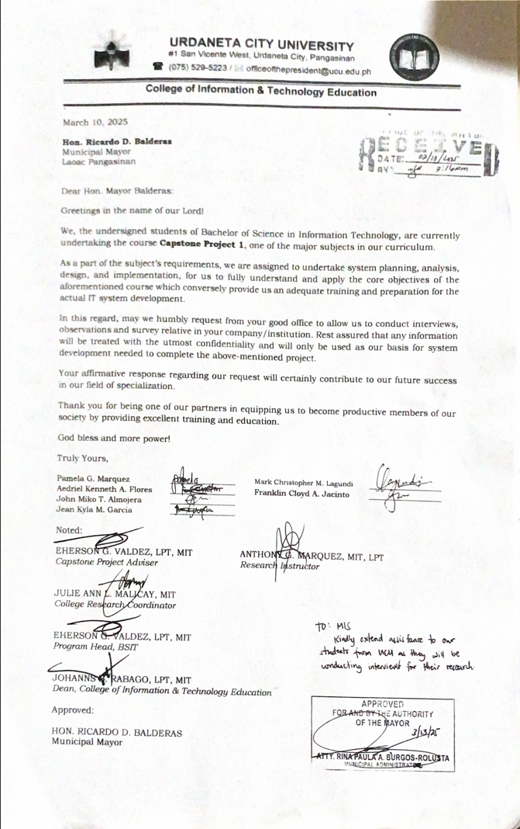

**APPENDIX E**

**Entity Relationship Diagram**

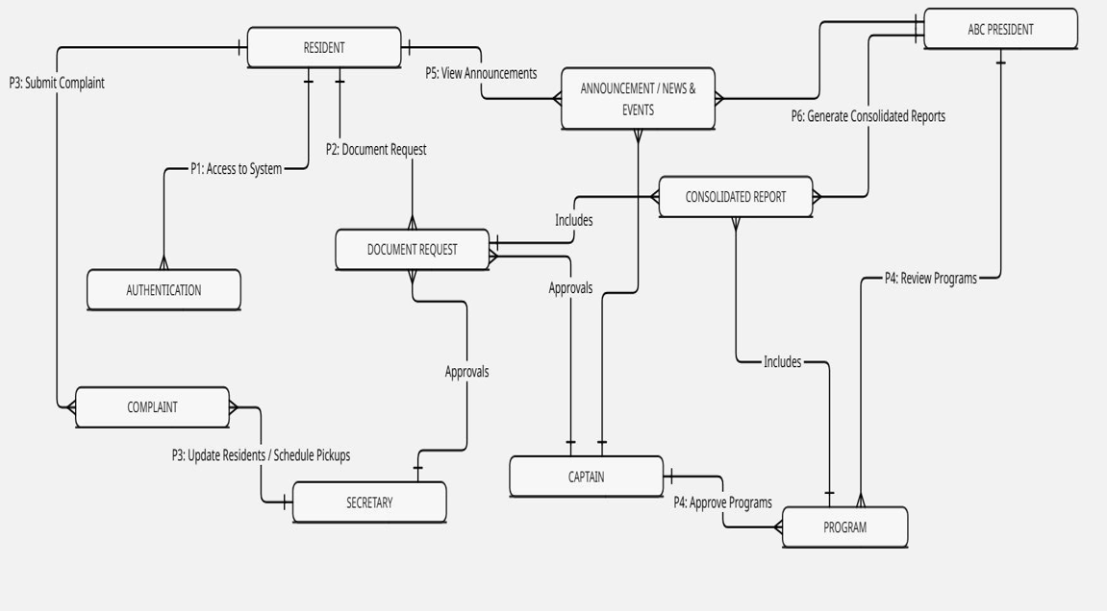

**APPENDIX G**

**Data Flow Diagram**

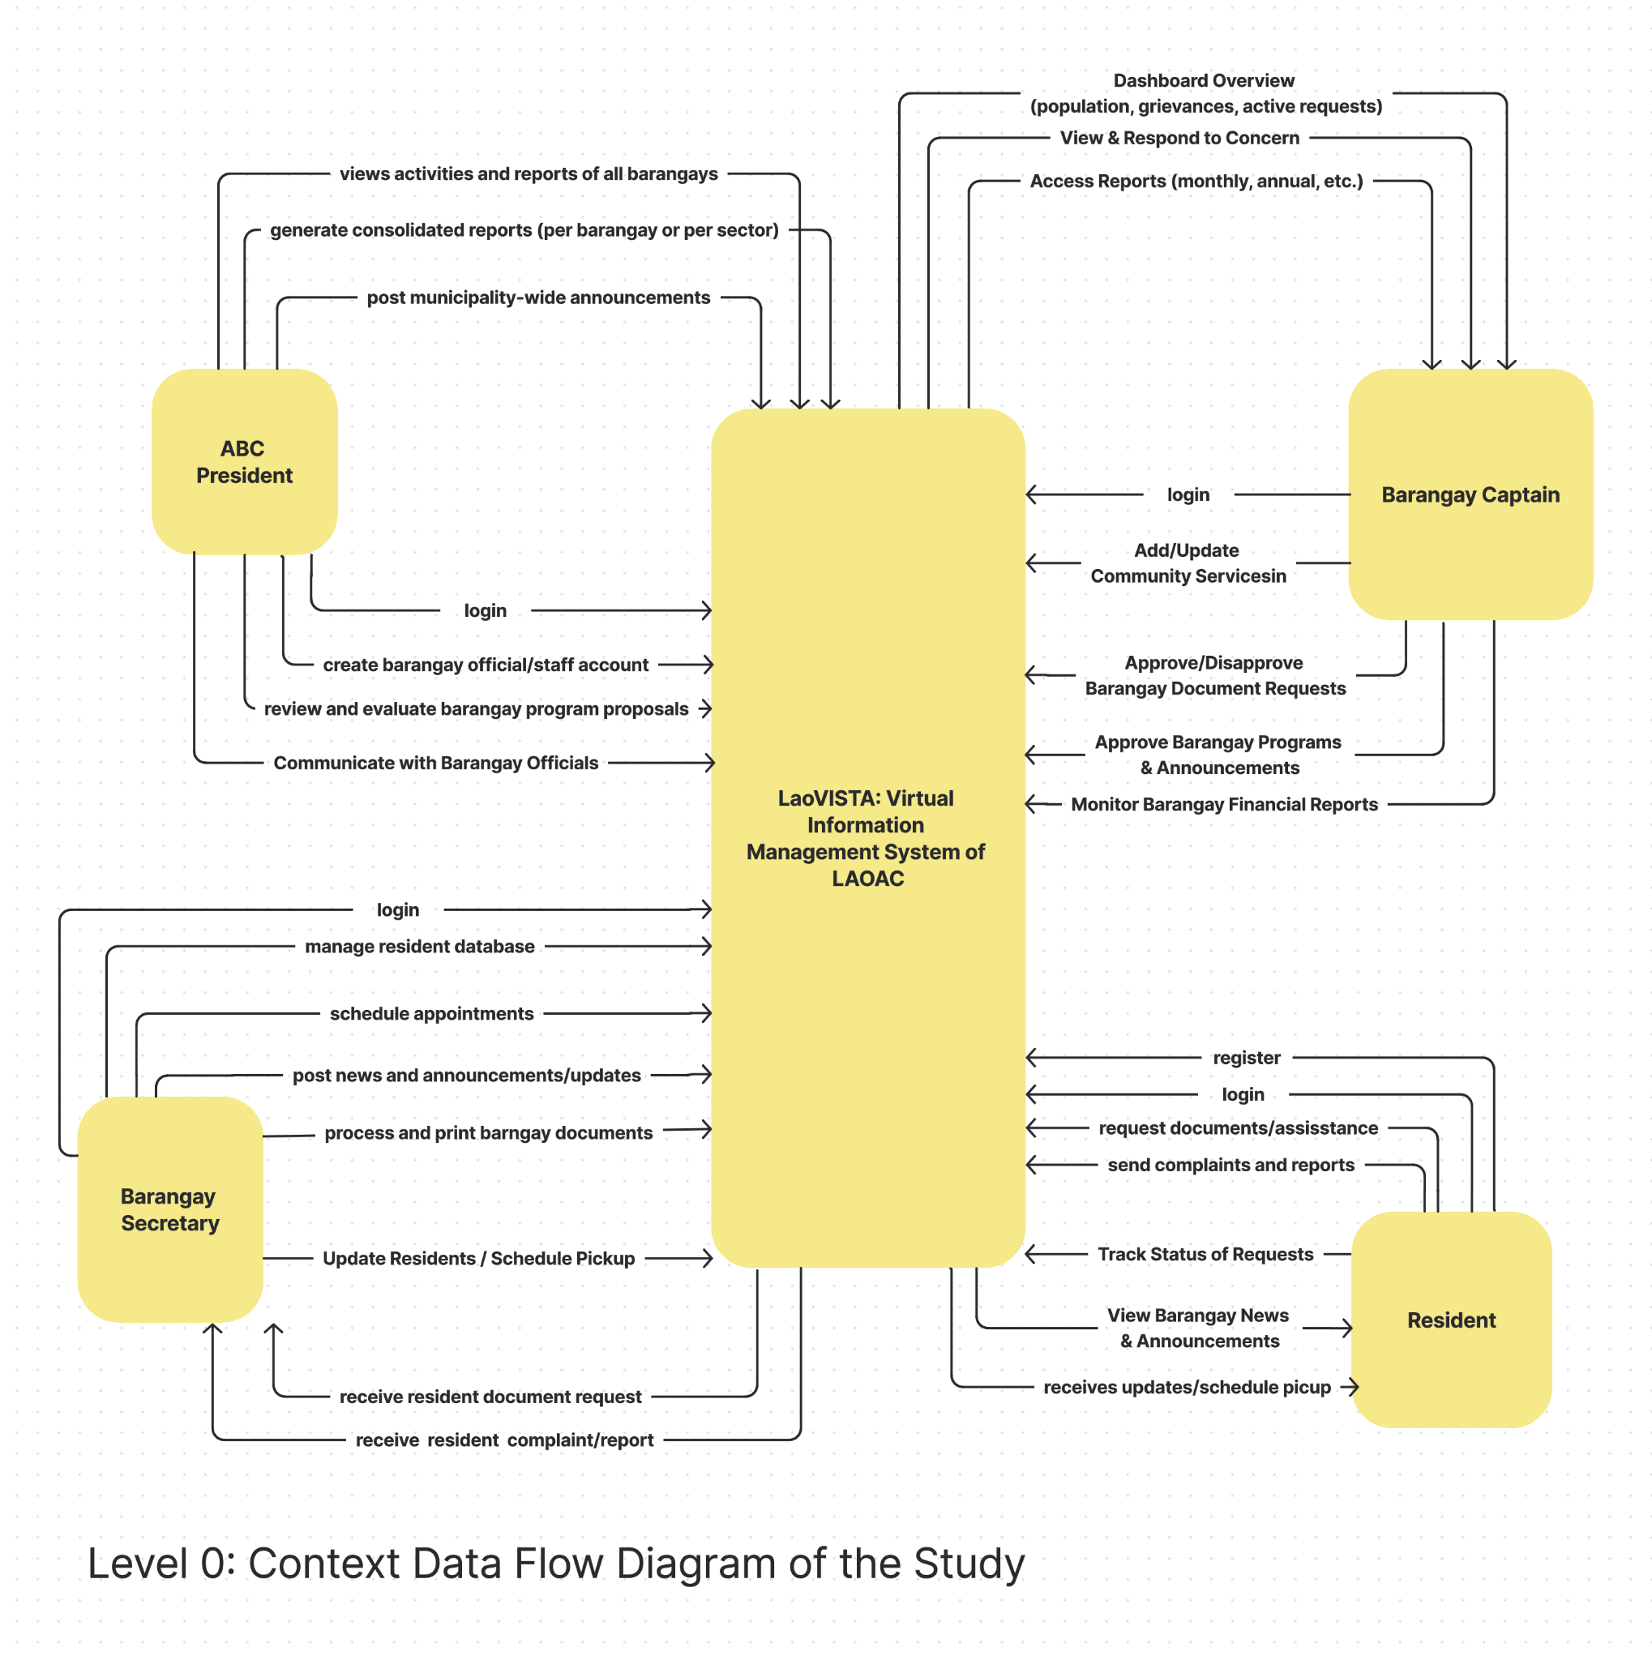

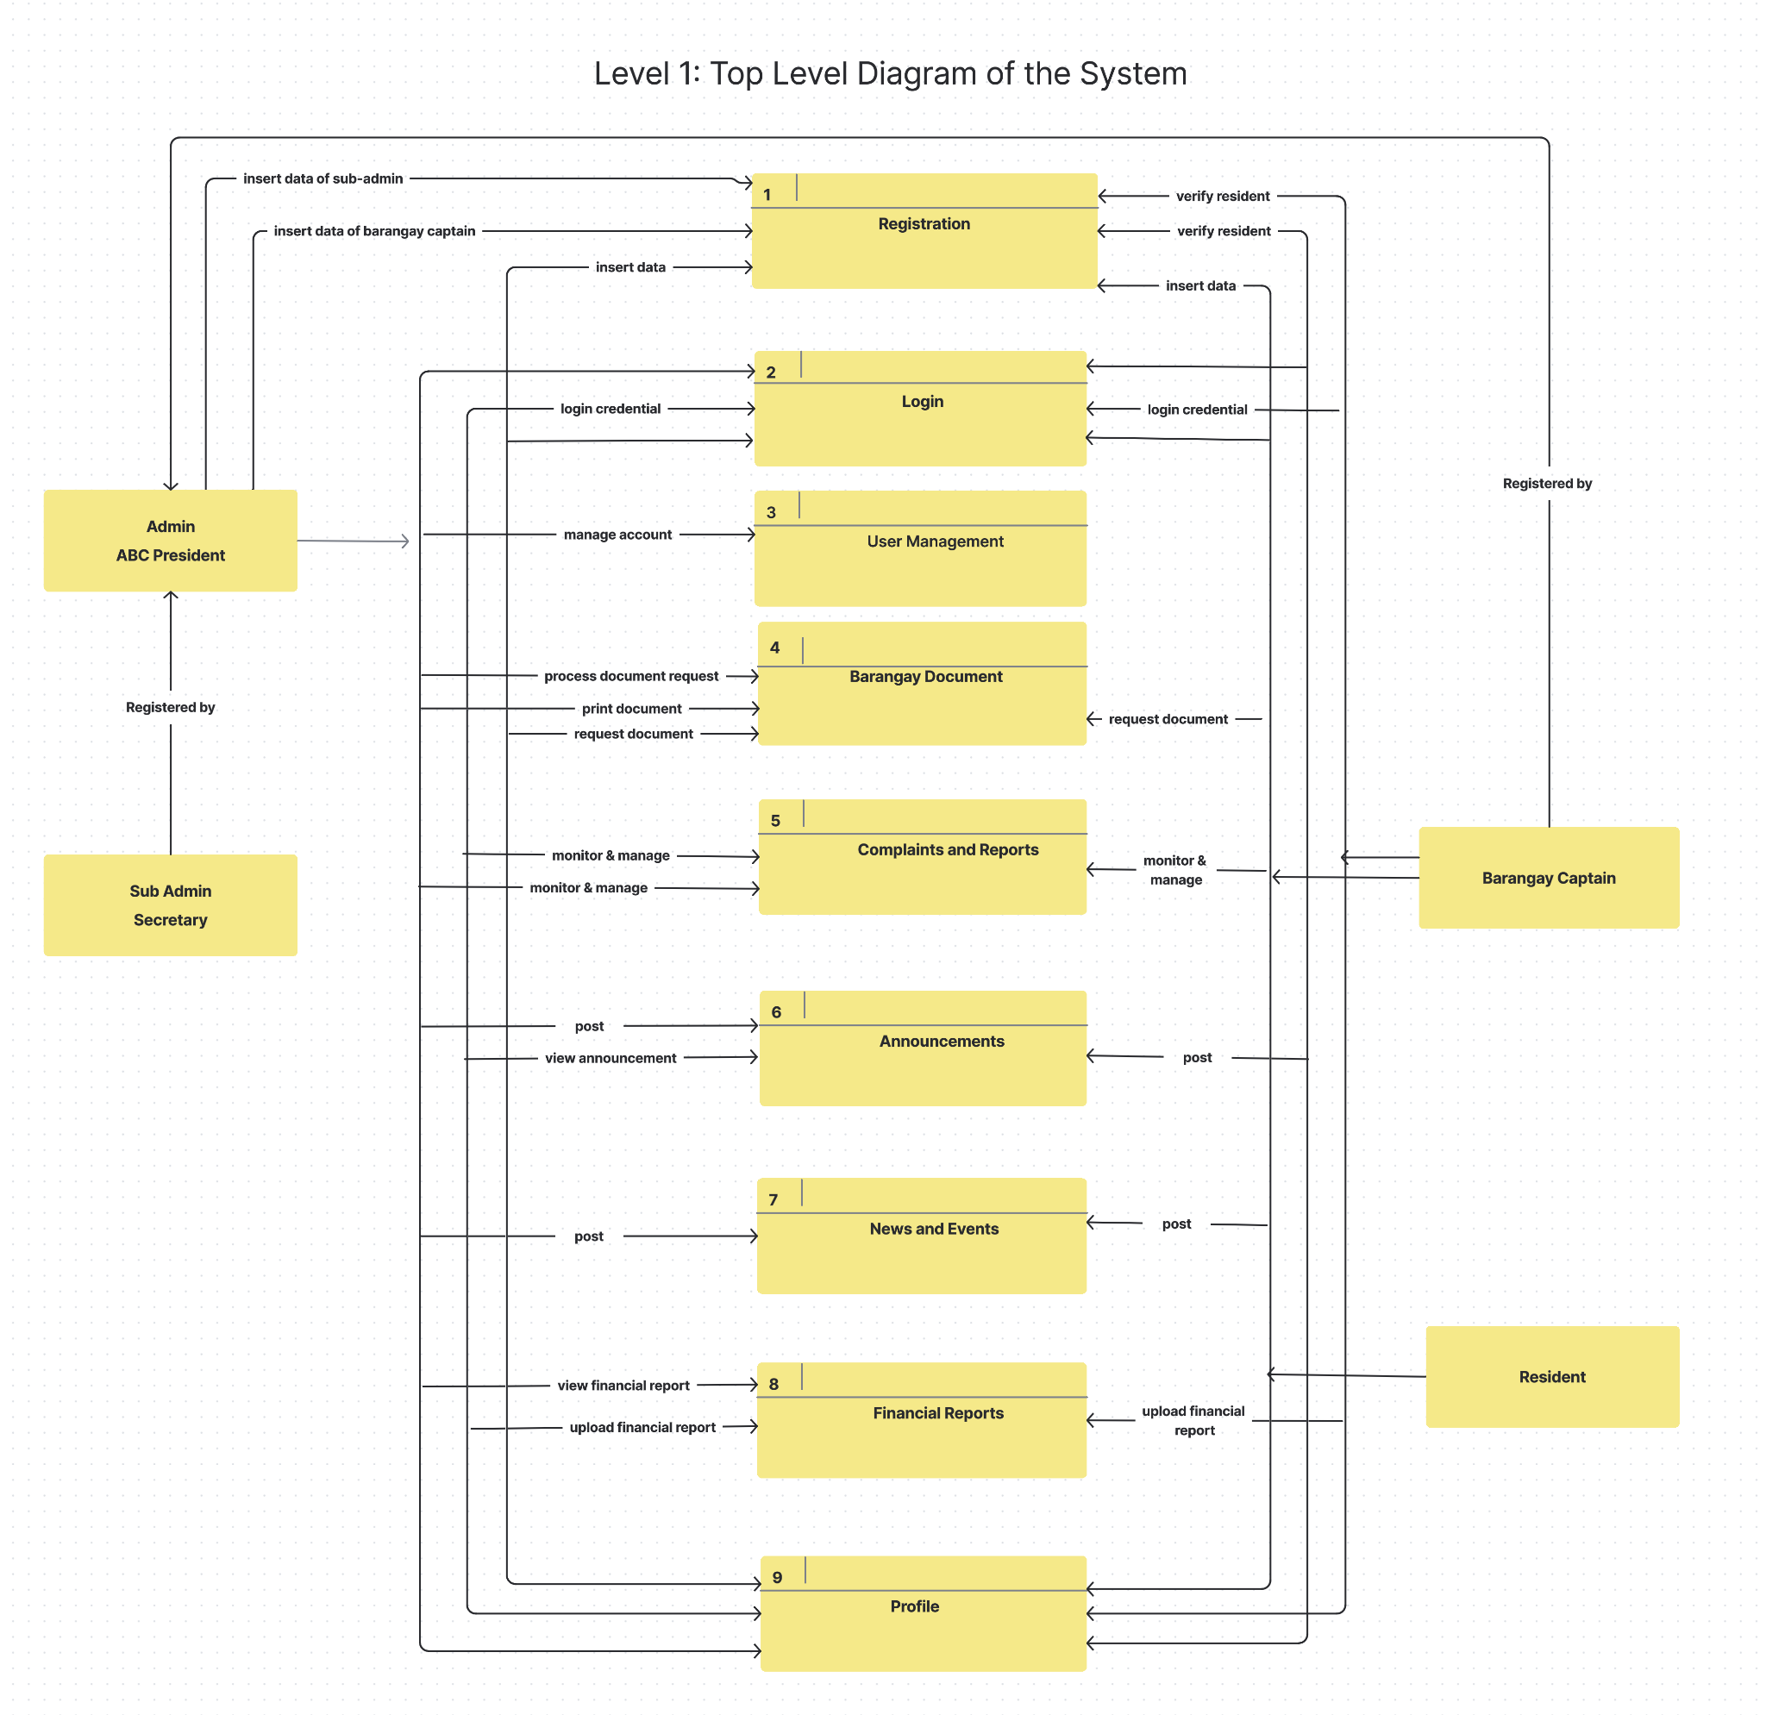

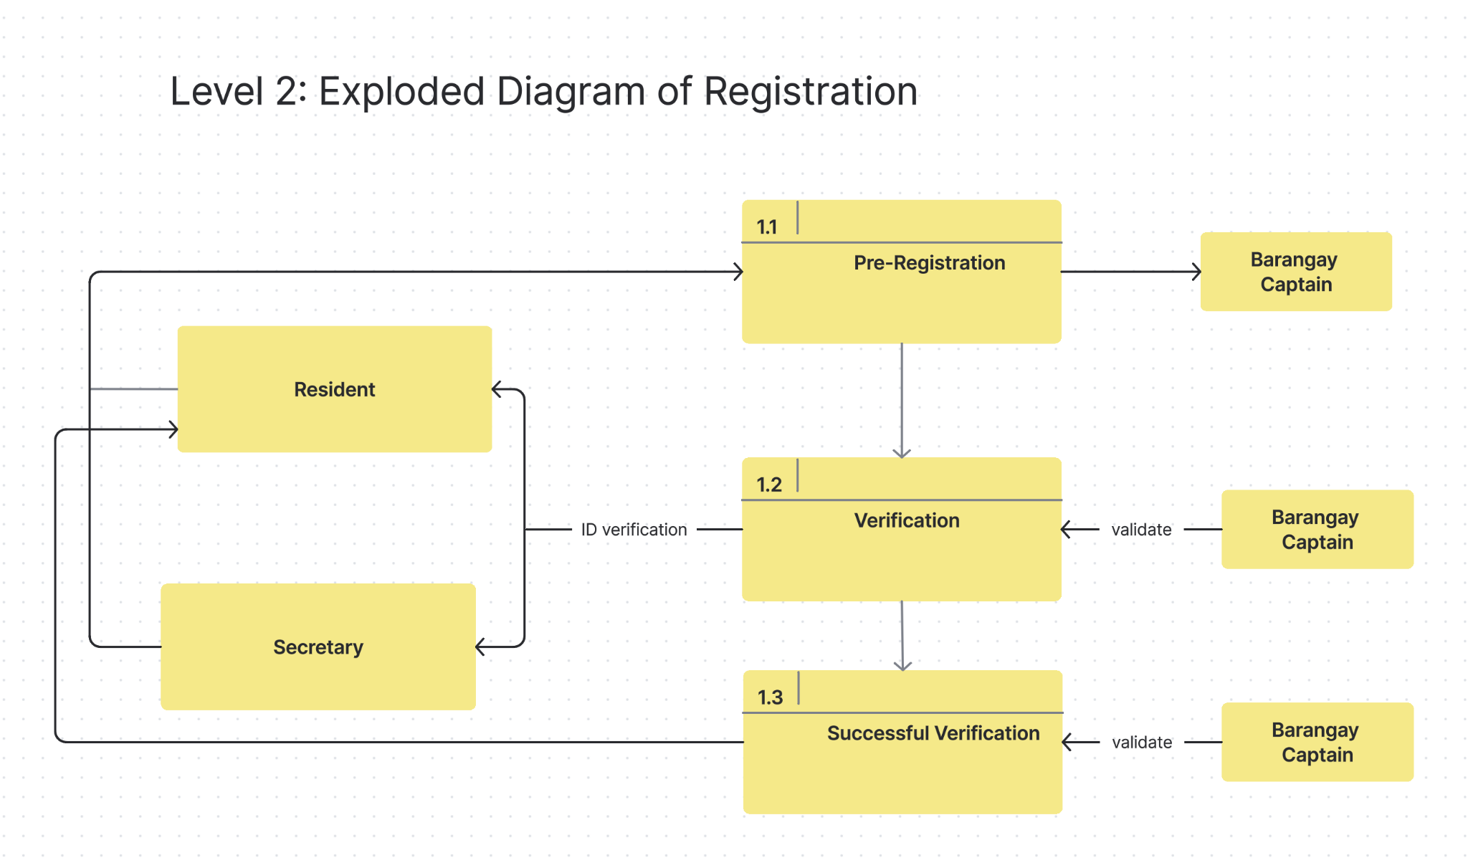

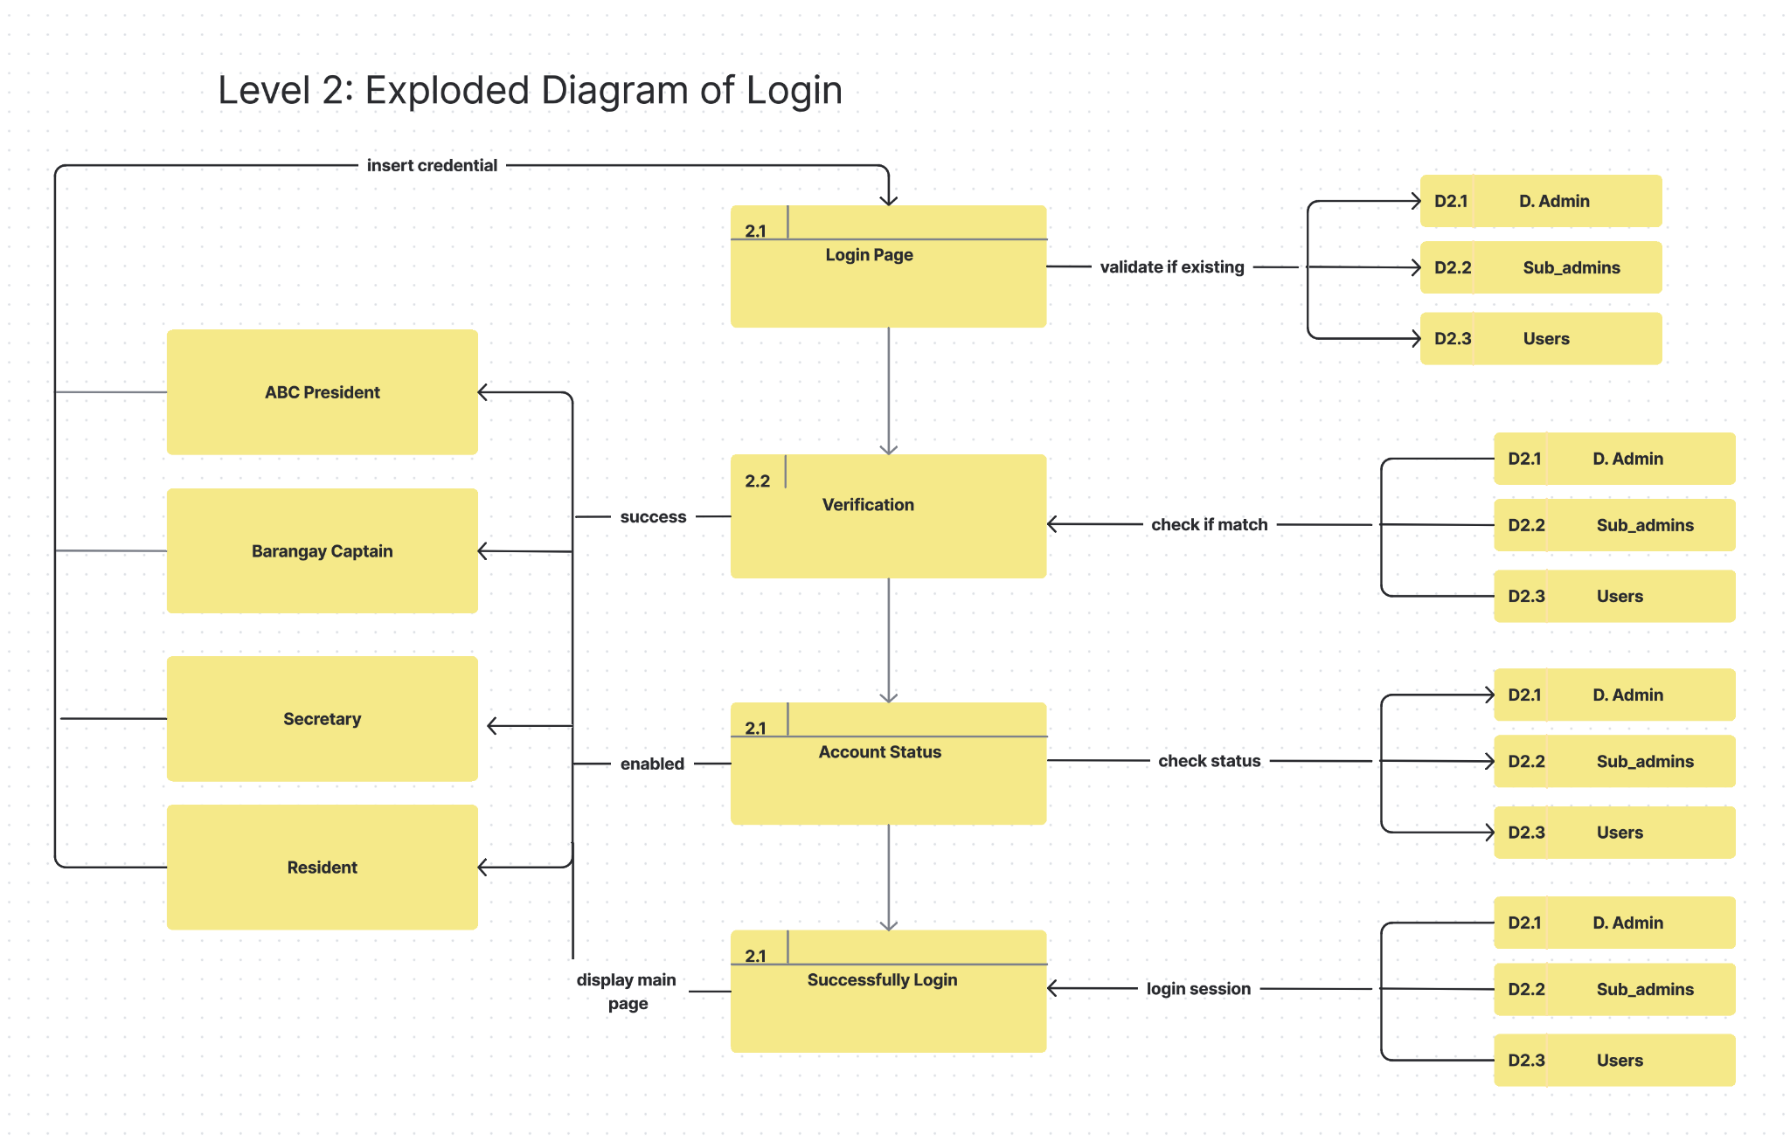

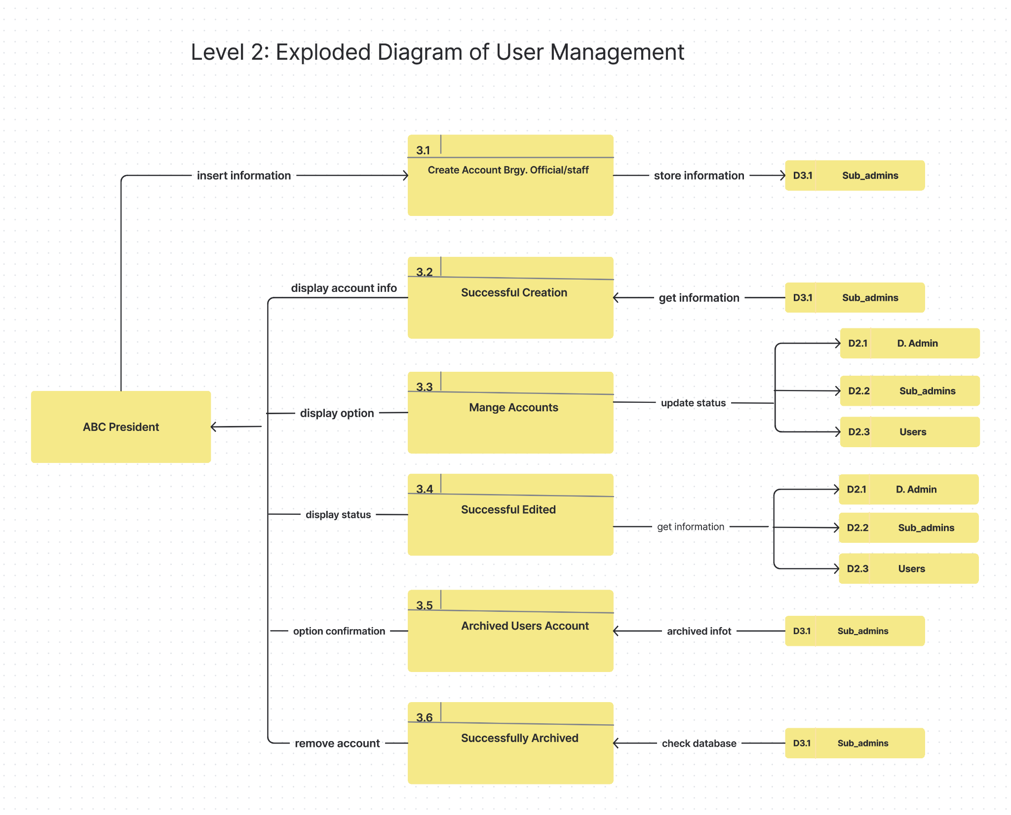

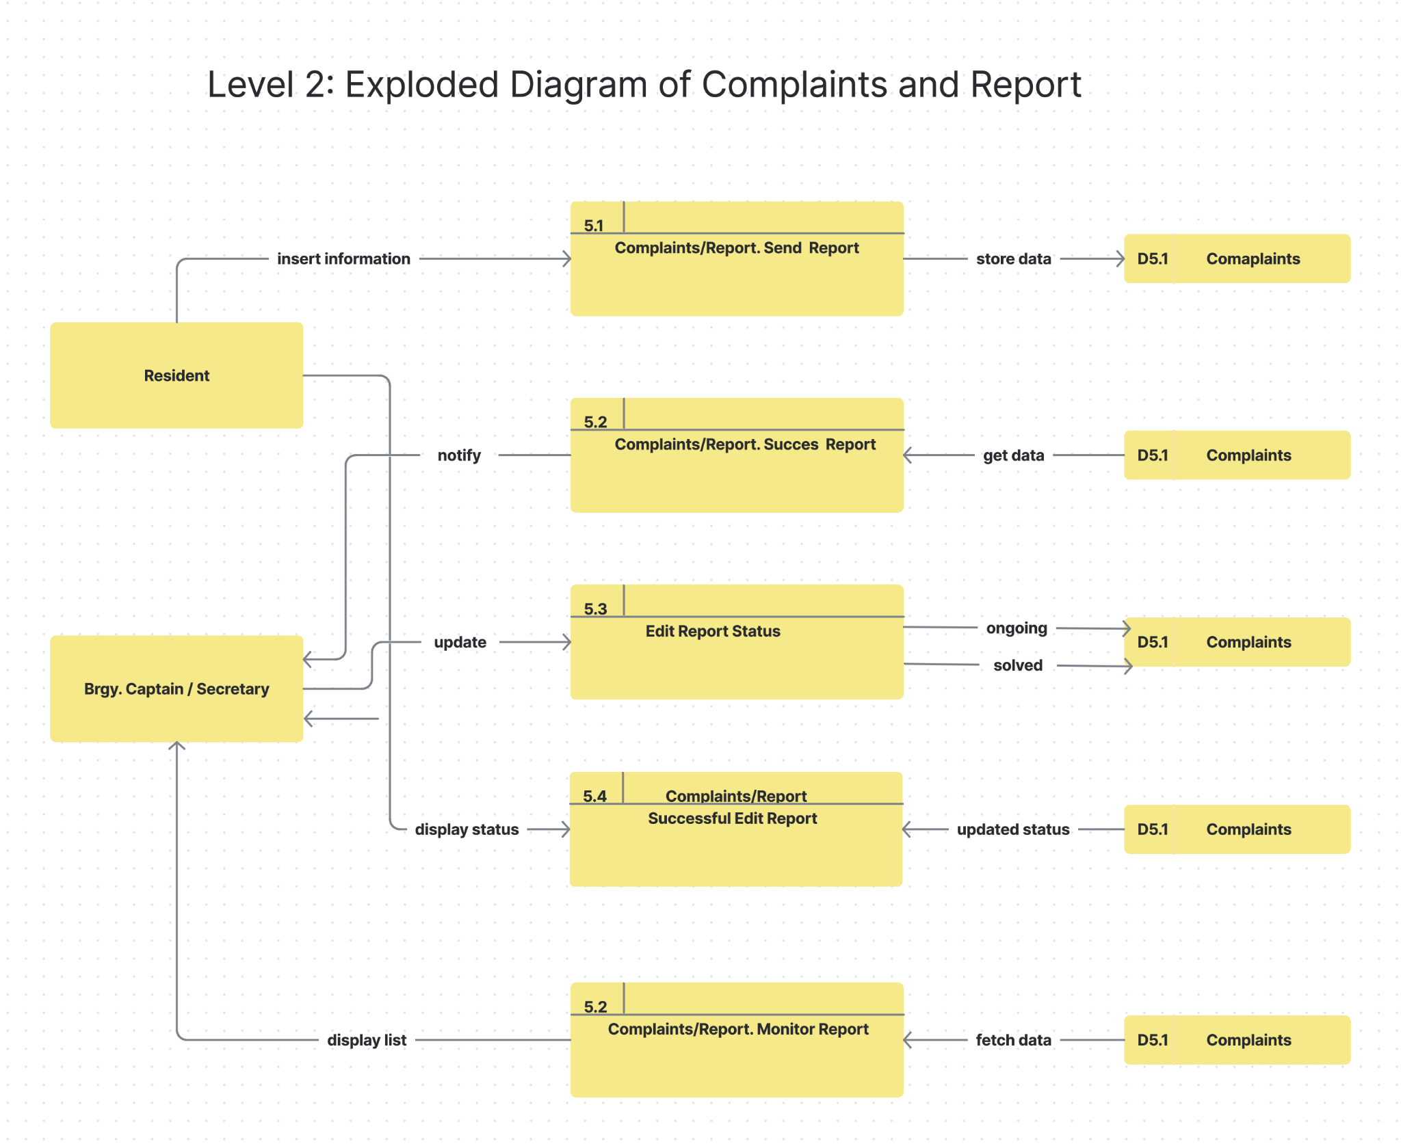

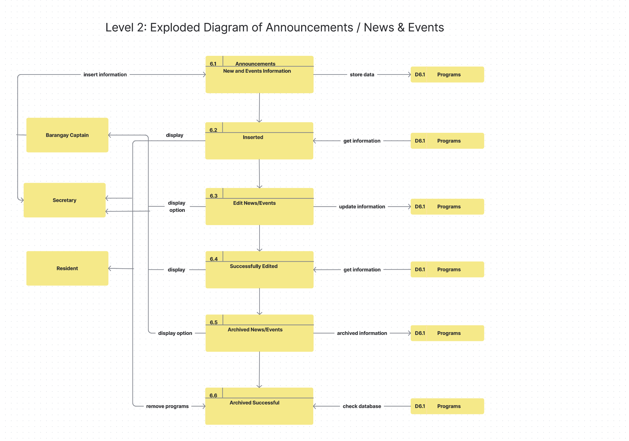

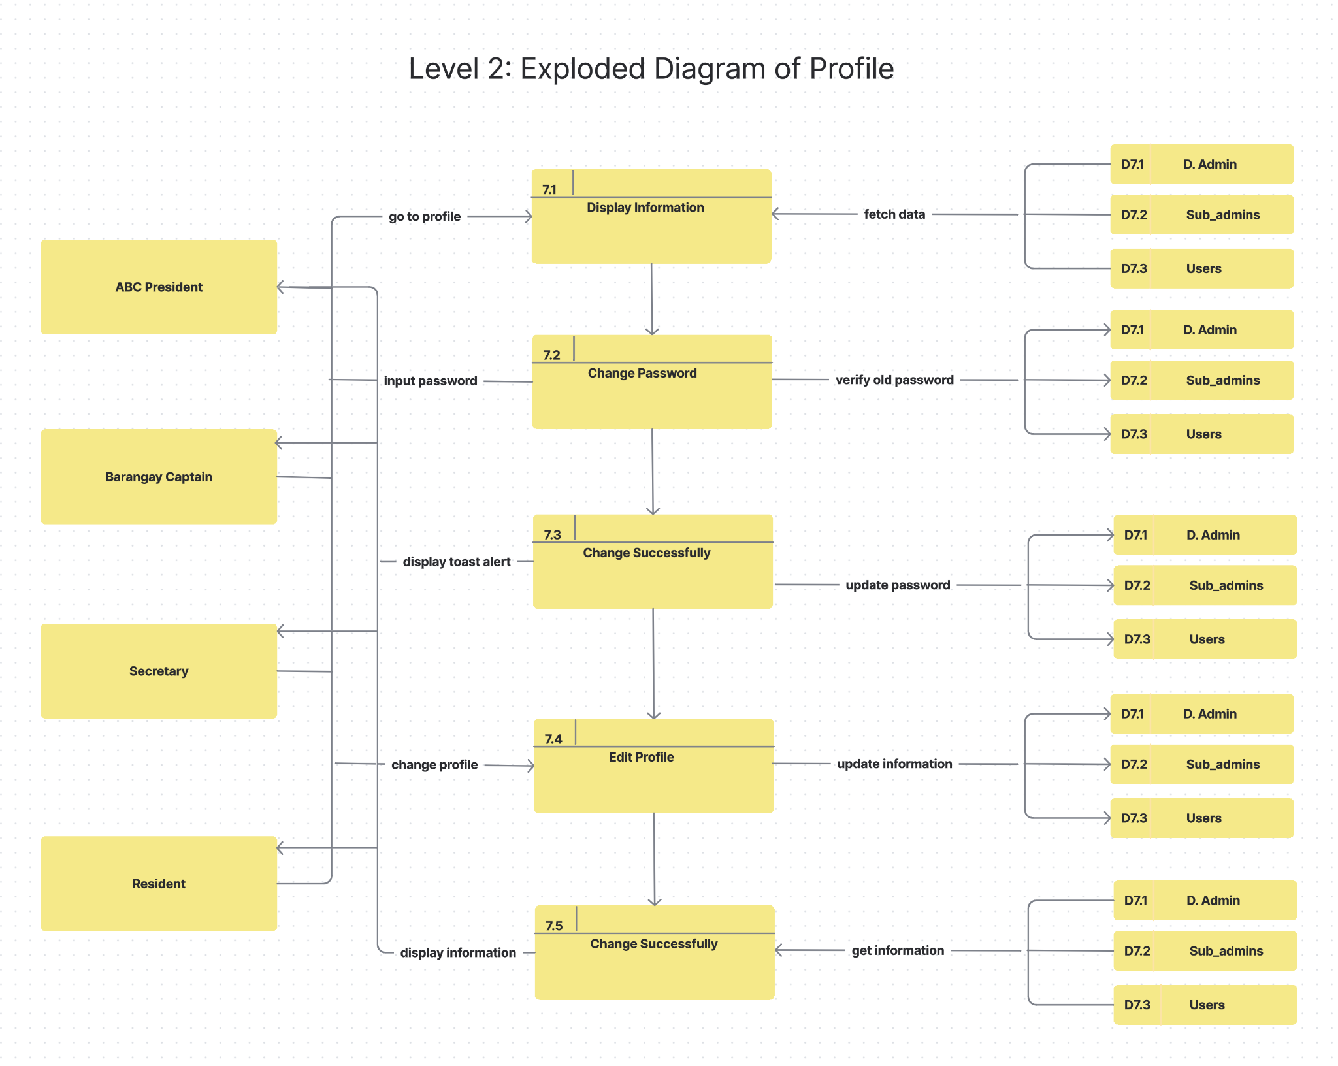

**APPENDIX G**

**Use Case Diagram**

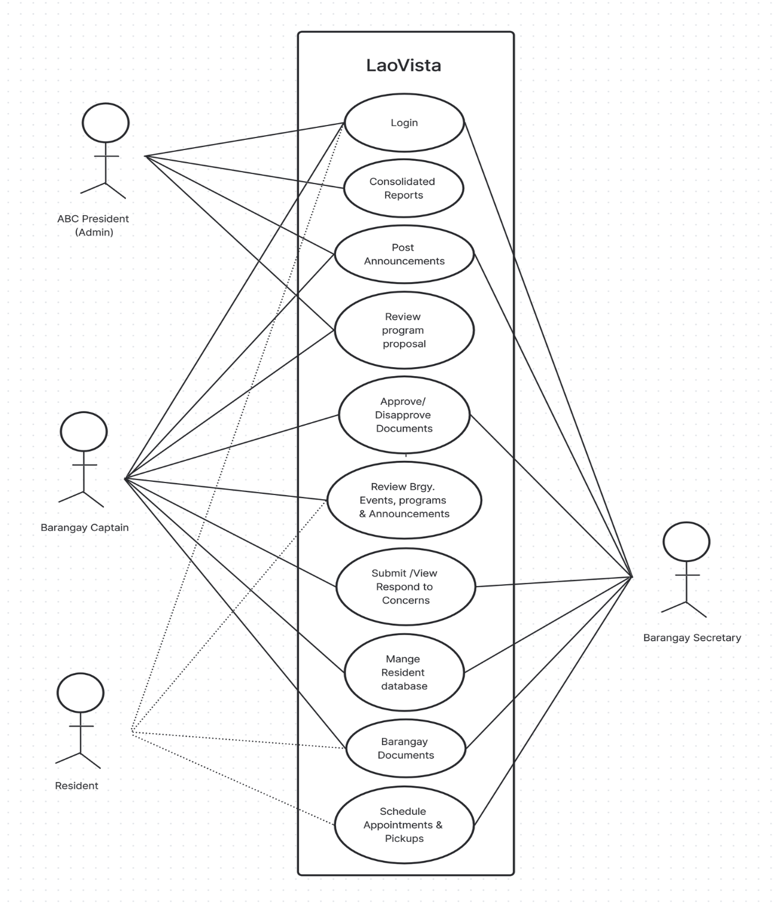

**Curriculum Vitae**

1. **PERSONAL INFORMATION**

First Name : Pamela

Middle Name : Galvez

Last Name : Marquez

Address : Calmay Laoac, Pangasinan

Birth date : August 8, 2003

Gender : Female

Status : Single

1. **EDUCATIONAL ATTAINMENT**

Elementary School : Cabanbanan Elementary School

Year Graduated : 2016

Junior High School : Manaoag National High School

Highschool

Year Graduated : 2020

Senior High School : Manaoag National High School

Highschool

Year Graduated : 2022

Tertiary : Urdaneta City University

Motto  : Everything happens for a reason

1. **PERSONAL INFORMATION**

First Name : Jean Kyla

Middle Name : Mabitasan

Last Name : Garcia

Address : Cal-litang Santa. Maria,

Pangasinan

Birth date : June 28, 2004

Gender : Female

Status : Single

1. **EDUCATIONAL ATTAINMENT**

Elementary School : Cal-litang Elementary School

Year Graduated : 2016

Junior High School : Eastern Pangasinan Agricultural

Year Graduated : 2020

Senior High School : Eastern Pangasinan Agricultural

Year Graduated : 2022

Tertiary : Urdaneta City University

Motto  : “Believe you can and you’re half way

there.”

1. **PERSONAL INFORMATION**

First Name : Franklin Cloyd

Middle Name : Agustin

Last Name : Jacinto

Address : Inamotan Manaog,

Pangasinan

Birth date : December 31, 2003

Gender : Male

Status : Single

1. **EDUCATIONAL ATTAINMENT**

Elementary School : St. Camillus College of Manaoag

Foundation Inc.

Year Graduated : 2016

Junior High School : St. Camillus College of Manaoag

Foundation Inc.

Year Graduated : 2020

Senior High School : St. Camillus College of Manaoag

Foundation Inc.

Year Graduated : 2022

Tertiary : Urdaneta City University

Motto  : "If you can’t survive, just try."

1. **PERSONAL INFORMATION**

First Name : Mark Christopher

Middle Name : Macanas

Last Name : Lagundi

Address : Oltama, Urdaneta City,

Pangasinan

Birth date : January 4, 2004

Gender : Male

Status : Single

1. **EDUCATIONAL ATTAINMENT**

Elementary School : Oltama Elementary School

Year Graduated : 2016

Junior High School : Cabaruan National High School

Year Graduated : 2020

Senior High School : Cabaruan National High School

Year Graduated : 2022

Tertiary : Urdaneta City University

Motto  : "If you can’t survive, just try."

1. **PERSONAL INFORMATION**

First Name : Aedriel Kenneth

Middle Name : Almuete

Last Name : Flores

Address : Ungab Cuyapo, Nueva Ecija

Birth date : June 26 2000

Gender : Male

Status : Single

1. **EDUCATIONAL ATTAINMENT**

Elementary School : Olra College Foundation

Year Graduated : 2010

Junior High School : Olra College Foundation

Year Graduated : 2016

Senior High School : Olra College Foundation

Year Graduated : 2018

Tertiary : Urdaneta City University

Motto  : "Try and Try until you succeed."

1. **PERSONAL INFORMATION**

First Name : John Miko

Middle Name : Telin

Last Name : Almojera

Address : Nancayasan, Urdaneta City,

Pangasinan

Birth date : June 17,1998

Gender : Male

Status : Single

1. **EDUCATIONAL ATTAINMENT**

Elementary School : Nancayasan Elementary School

Year Graduated : 2010

High School : Mariano Q. Umipig National

High School

Year Graduated : 2015

Tertiary : Urdaneta City University

**Motto**  : “In God We Trust”